Breakfast

THE most important meal of the day!

This is why children should have an array of choices to encourage them into good eating habits.

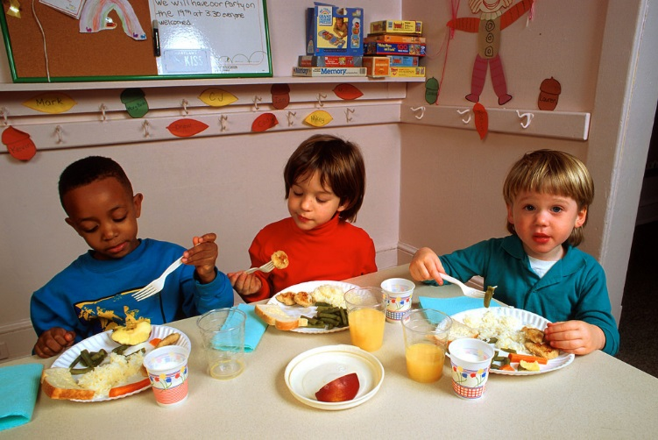

All our breakfast cereals are fortified with vitamins and iron, and each day an additional choice of 2 other wheat-based products are available along with fruit.

(e.g. Wholemeal toast, plain and fruit bagels, pancakes, crumpets & potato cakes)

